Follow the same formatting guidelines as the previous homework assignment.

Copy and paste the contents of student.txt (Same as the previous lab) into your SQLPlus session. Rename the tables such that they are all prefixed with the first five letters of your lastname such as sabze_student. Make sure that the tables (student, classes and student_class) are all renamed properly before you continue.

Use only a single SQL statement for each of the following questions
1 | Give a listing of all the ssns,first names and the class descriptions of  all the classes the students are taking. If there are no class _descriptions  display 'No description is available yet'. (USE NVL)
 | 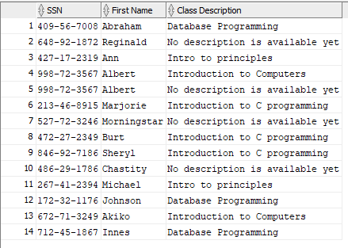
2 | Give a listing of only the lname and the class_code for  students who are taking 'Introduction to C programming'. (Inner join)
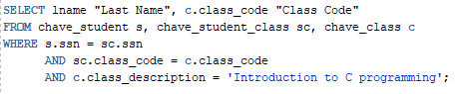

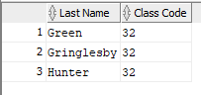
3 | Give a lising of all the class_descriptions and the number of  students enrolled in each class for all students who are older  than the average age where the total number of students for the class  is more than 1 student. Order by the number of students. If there  is no class description replace it with 'Other Classes'  (Note: Take it in steps. First do all those who are older than the average age, then do the group by, then add the having clause and then the order and then combine everything together)
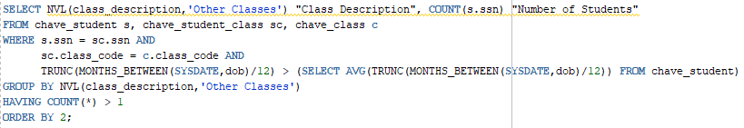

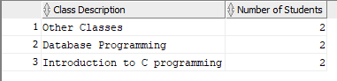
4 | Give a listing of all the classes for which no students are  enrolled in (use in or not in clause) (subquery)
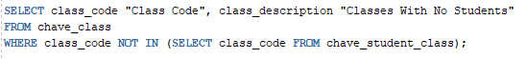

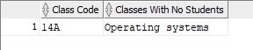
5 | Give a listing of all the students who are not enrolled in any  classes (Note: Use Exists or not Exists)
 | 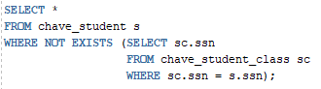
6 | create a new table that contains the list of all the students  and class_descriptions. Include In this table the list of all  students who are not enrolled in any classes (display no classes). If there are no class descriptions then display ‘no description’  (Use combination of inner join, union and minus)  (Note: minus will deal with the students who are not enrolled in any classes)
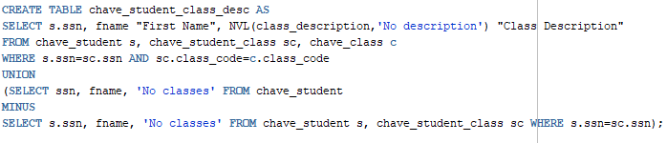

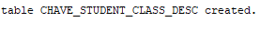

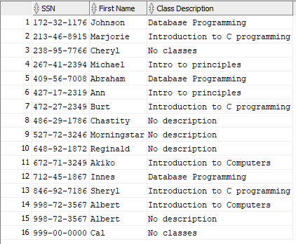

7 | repeat question 6 using a combination of inner join, union and not exists  (Note: Not exists will deal with the students who are not enrolled in any classes)
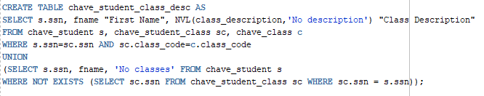

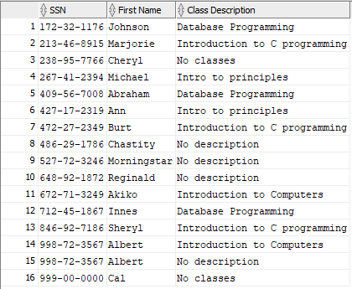

8 | create a view. We want to find out which courses are being taken by the different students for all those whose age is greater than the average age. Give a listing of the course descriptions and student names (Inner join)
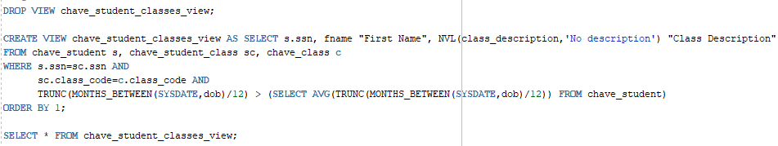

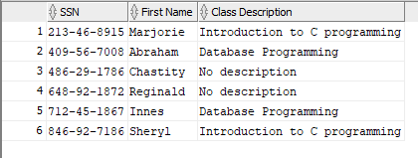

9 | We want to find out the courses that each student is not enrolled in.  Give a listing of the course descriptions, and the students (lname) who are not taking that specific course  (Use a cartesian product and union it with a minus)
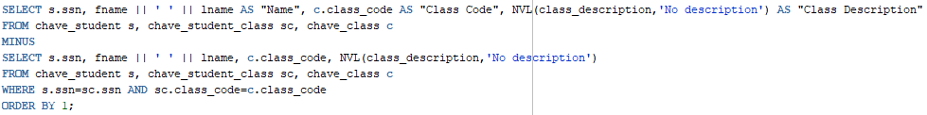

NOTE: The whole output was 91 lines long. Only the first 18 lines are shown below.
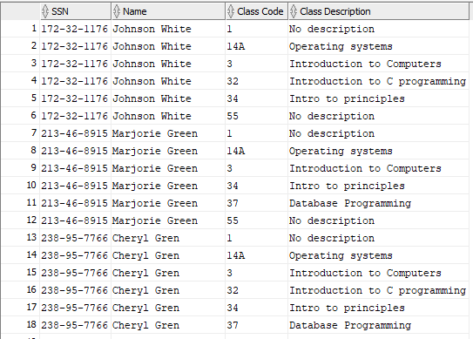
10 | Use the system catalog tables to display the results to find out the  following:(Note show me the SQL syntax along with your results) Only a single SQL statement for each question.
 | a) Primary key name and the columns that make up the primary key for student table
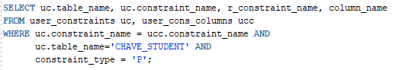

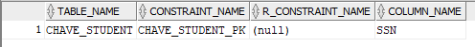

 | b) Unique key name and the columns that make up the unique key for the student table
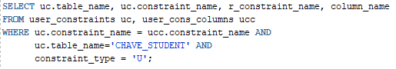

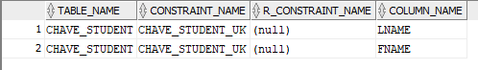
c) Foreign key name, the columns that make up the foreign key
and the columns it references in the parent table for student_class table
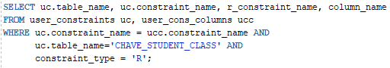

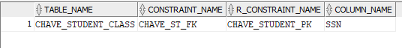
 | d) Name of all the check constraints and their conditions for the student table
